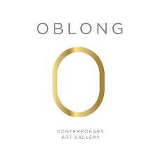
The Adventures of Pinocchio

“Pinocchio is not just a companion in Art but a companion in Life” - Antonio Nocera

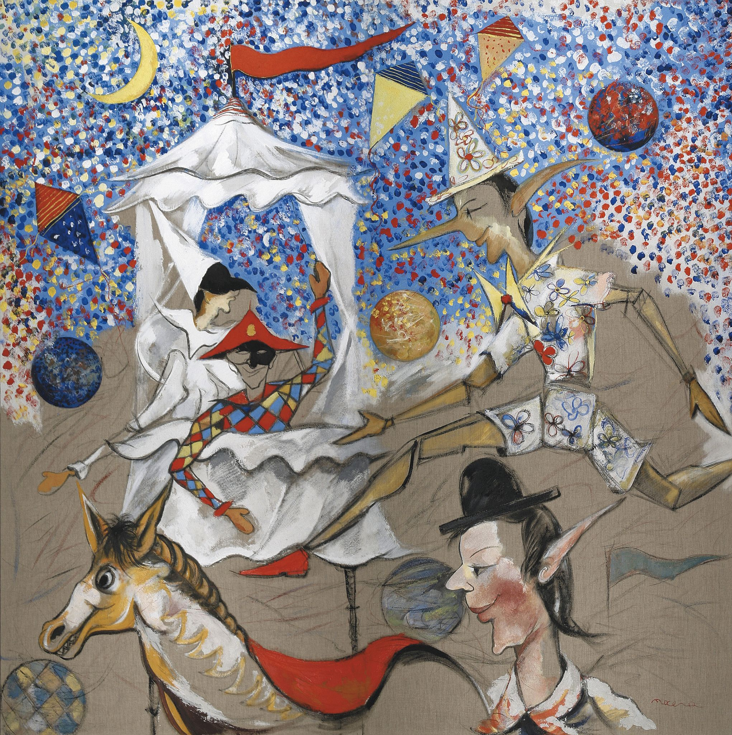

Oblong Contemporary Gallery unveils a nostalgic exhibition “The Adventures of Pinocchio” by Italian artist Antonio Nocera that will run from the 15th December 2021 until the 31th of January 2022.

The famous Pinocchio film and Disney classic that shaped our childhood, and learning our first lesson around the importance of lying, is a tale of morals we carry throughout our lives. It was in the year 2002, Antonio illustrated a book “The Adventures of Pinocchio”. In the same year he inaugurated the exhibition “Pinocchio et la Lune '' at Paris Municipality, then at the European Parliament in Brussels, with the introduction of the former President of Italy Giorgio Napolitano.

In the story, the mischievous and young Pinocchio, always up to no good had said to a wise cricket,
“I shall be sent to school and shall be made to study either by love or by force. To tell you in confidence, I have no wish to learn; it is much more amusing to run after butterflies, or to climb trees and to take young birds out of their nests.”

The butterflies can be seen in most of Antonio’s works. He says they’re a reflection of freedom and spiritual change in the world. As for the fairies, sweet and severe at the same time. The fairy is like a mother born for everyone in the world.

From sand to sawdust, from glass to canapa, Nocera experiments with a wide spectrum of materials to ignite different effects on a canvas to make them appear three-dimensional and ‘sculptural like’.

The wooden-nosed Pinocchio has been a strong inspiration over the years of his life. Every time he revisits the story, he finds a new perspective on the moral that has stayed very close to him. Which is why the figure of Pinocchio has been prevalent in Antonio’s works for over two decades. For Antonio, Pinocchio only speaks the truth and never lies, - similar to everyone else. He sees the human in the story.

Antonio makes us realize that whoever knows how to play lives better, whoever knows how to laugh escapes sadness, whoever imagines lives twice: a normal life like everyone else and one made up of dreams and fantasy.

Antonio has collaborated with the Carlo Collodi National Foundation for the past 20 years, which has sponsored all of his books dedicated to Pinocchio. In 2015, the book was presented at the Institute of Italian Culture in London as a patronage of the Carlo Collodi National Foundation in the presence of its President, Pier Francesco Bernacchi.

- ends-

For High-res images please click here - https://we.tl/t-D34BJt0uT8

About the artist:
Antonio Nocera was born in Caivano (Naples), Italy, in 1949.
He studied at the Napoli Art High School and at the Napoli Fine Arts Academy, attending painting, sculpture and scenography classes. He also took interest in the manufacturing of leather, ceramic and all printing techniques. Nocera has lived in multiple cities in Italy such as Rome, Parma, Milan, Venice to name a few. He has created masterpieces in collaboration with international in-situations such as the European Parliament, UNESCO, Onu and Unicef.

Maestro Antonio Nocera has been recognized for his work on Pinocchio by His Holiness Pope Francesco in 2016.

About the gallery:
Oblong Contemporary is an Italian art gallery specialised in the promotion of contemporary art by established and emerging international artists. Established in 2019, Oblong collaborates with unique talents by providing them a local and international platform and by ensuring a high level of value across our location in Dubai and Forte dei Marmi. As a gallery, Oblong is committed to representing a successful arena for culture, functioning as a bridge between Italy and the UAE.
Contact us at oblongcontemporary.com

For more information, please contact:
Giulia Filiè: marketing@oblongcontemporary.com | +971 54 348 2287 (Marketing inquiries)
Laetitia Tregoning: laetitia@story-pr.com | +971 56 724 2154 (Press inquiries)
Natascha Law: natascha@story-pr.com | +971 56 314 8798 (Press inquiries)

