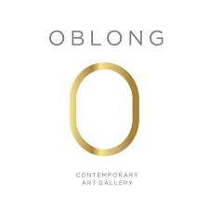

Max Vadukul: Moody Timeless

«Idea inspired totally and 100% by my story and by one woman, Ludmilla»

Oblong Contemporary Gallery presents Moody Timeless by Max Vadukul
from the 1st till the 25th of November.

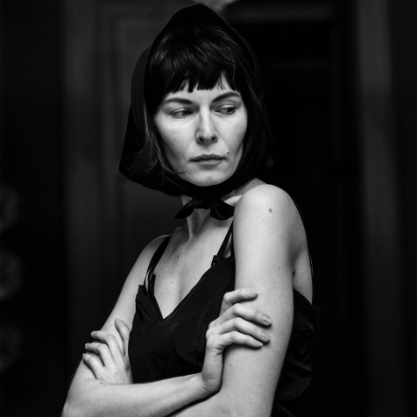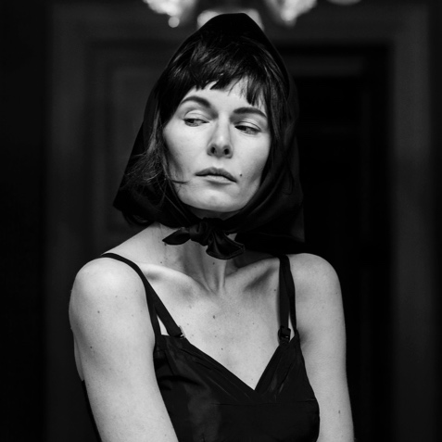

Moody Timeless #36, Moody Timeless #37, photography, 2022.

DUBAI, 1st November 2022 – Oblong Contemporary Gallery in Dubai presents the exhibition "Moody Timeless" by Max Vadukul, artist known for his art reportage photography, which he describes as “taking reality and making it into art.”

Max Vadukul born in Nairobi, Kenya, in 1961 to Indian parents is a British photographer who works worldwide, now based in Milan since 2019. In mid 2021 he had the occasion to photograph The Zero Collection for Roberto Cavalli by Fausto Puglisi. The collection remains stunning and true to the designer’s code. A major casting was done and the two days photography will remain “Timeless” for the fashion house and for him.

One of the models was Ludmilla Voronkina Bozzetti, Max was very impressed with Ludmilla and he remembers: “Firstly she did not come through my lens as a “model”, she was different, really different. I sensed something that I only see rarely in women. She had a story and a past; a real strength and I began to shoot more and more on her. She had a touch of steel and her transition through my lens was razor sharp . Indeed I felt like having discovered someone with whom I could make strong Vadukul images. I wanted to do a “Fine Art Project with her”.

The Treatment
The Location has been a Villa outside of Milano frozen in time and has been used to create the tale of a timeless memory of Ludmilla who has been styled cinematographically by the legendary stylist Nicoletta Santoro. The images portray her past and the spirit Max wanted to bring to this was the domestic worker in the house with a twist. Over a period of to 2 to 3 days shooting Ludmilla went through transformations in her character and travelled to the present day. Max looked at different looks that simulate a time travel of a ’Portrait of a Lady ‘, that testifies the timeless role of the woman in the society. In this extraordinary work Max employed the best stylist, hairstylist and make up artist he could get, keeping in mind that this is not a “fashion shoot”! It is an outstanding timeless artwork where the photos, the images are the king and will live for ever in a exhibition and a published book.

The Concept
Despite the time passing, the true values remain the same and the woman has always played a central role in the society and in the family.
It doesn’t matter if she is a child, a woman, a mother, a grandmother, a wife, a businesswoman or an housewife: she is always protagonist and powerful as it appears in these artworks. It is incredible to see these outstanding photographs that are real art pieces where the varied feelings of the model are captured, blended and enhanced by Max Vadukul’s extraordinary art in a perfect fusion of art and emotions. In these incredible, timeless images sometimes Ludmilla looks absorbed in her thoughts and detached, sometimes she is doubtful and then very self confident and sure to have won. You find her also serious and then smiling and ironic or you can feel when she abandons herself to the emotions with a veil of sadness and pity, but then you suddenly find her again full of power and determination.

Exhibition Details -

Exhibition: Moody Timeless
Dates: 1st – 25th November
Location: Oblong Contemporary Gallery, Bluewater Island, Dubai
Timings: 10am - 10pm, everyday

About the Artist:
Max Vadukul (born 2 February 1961, Nairobi, Kenya) is a British photographer who is based in New York City. He is noted for his art reportage photography, which he describes as “taking reality and making it into art.” He has a lifelong affinity with black and white photography, a foundation of much of his early work. From 1996 to 2000 Max was the staff photographer for The New Yorker, second after Richard Avedon and is the first Indian photographer to shoot covers for French and American Vogue. Sting has described his photography as a sort of "On the move style". The National Geographic channel produced a feature documentary on Vadukul in 2000 about the improbable arc of his life after Africa; the documentary continues to air around South Asia today.

- ends-

About the gallery:

Oblong Contemporary is an Italian Art Gallery specialised in International Contemporary Art. Established in 2019, Oblong collaborates with unique talents by providing them a local and international platform and by ensuring a high level of value across its locations in Dubai, Forte dei Marmi and Firenze. Oblong is committed to representing a successful arena for culture, functioning as a bridge between Italy and the UAE.
Contact us at oblongcontemporary.com

For more information, please contact:

Giulia Filiè: marketing@oblongcontemporary.com | +971 54 348 2287
(Marketing inquiries)

